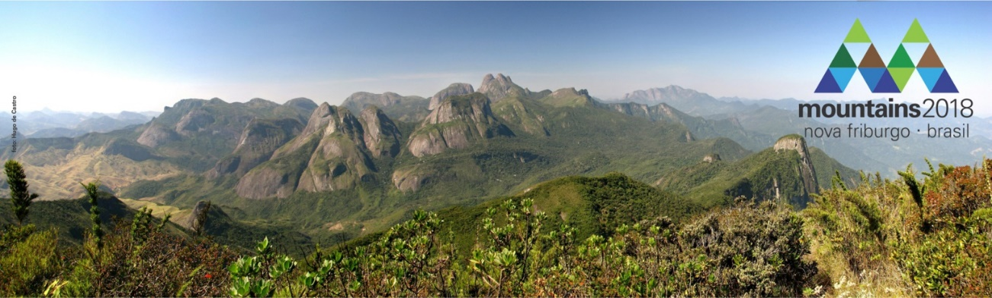
Call for symposia

The II International Conference on Research for Sustainable Development in Mountain Regions, to take place in Nova Friburgo, Brazil, on 12-14 December 2018, invites proposals for symposia (parallel sessions during the conference). These proposals should be prepared using the attached form and submitted by 31 January 2018 to mountains2018.br@gmail.com

The II International Conference on Research for Sustainable Development in Mountain Regions is part of Mountains 2018, an international event aiming to promote sustainable development in mountains, based on science, knowledge, and innovation. Mountains 2018 takes place two years after Mountains 2016, held in Bragança, Portugal. Further details about Mountains 2018 can be found at http://www.mountainsbr.com/EN/

The aim of the conference is to share innovative experiences of mountain scientific knowledge, and promote debate on new directions and on how research can contribute to practice. All symposia should contribute to the overall theme of ‘Connecting science to practice’ and be linked to the implementation of specified Sustainable Development Goals (SDGs) for 2030.

Timeframe
- Deadline for submission of symposium proposals: 31 January 2018
- Announcement of results (accepted symposia): 3 March 2018
- Deadline for submission of abstracts for papers: 31 May 2018
- Announcement of results (accepted papers): 30 June 2018

Symposium proposal application

Symposium title:

Proponent(s) and affiliation:

Abstract outlining the theme and relevance of the symposium (maximum 200 words):

Sustainable Development Goals (SDGs) to which this symposium relates (see http://www.mountainsbr.com/EN/pg/temas )

Possible speakers´ names, affiliations and (if possible) tentative titles of presentations:
1.
2.
3.
4.
5.
…

Please submit your application by email to mountains2018.br@gmail.com

